

Team Oriented Project Studies

BHA 4704

Proposal

Design and development of remote-controlled actuator to control car throttle on chassis dynamometer

**Students**Nurain Binti Rozy  
Muhammad Syakir Bin Turiman  
Muhammad Nor Azril Bin Zulkafli  
Lorenz-Leo Wilhelm  
Uli Michael Hochreither  
Jakob Kleikamp

**Project Supervisor**Dr. Saiful Anwar  
Dr. Daing Nafis  
Dr. Melya

Table of Content

Abstract 2

Introduction 2

Project Scope 3

Project Deliverables 3

Project Acceptance Criteria 3

Project Constraints 3

Literature Review 4

Methodology 6

Planning 6

Requirement Analysis 6

Design 6

Development 6

Integration and Testing 6

Implementation 6

Operation and Maintenance 6

Materials 7

Machines 7

Electrical Systems 7

Tools 7

Manual Design Calculation and CAD Drawing 8

Selection of Criteria 10

Actuator comparison 11

Detailed Cost Estimation 12

Expected Testing Results 13

Conclusions 13

Project Gannt Chart 13

Team Organisation 14

References 15

Table of Figures 16

# Abstract

The objective of this project is developing an actuator to control the throttle of a car on a chassis dynamometer so it will be possible to accelerate the car. The actuator will be controlled remotely with software running on a different device. The device will be connected to the internet so at any time and any place around the world if there is internet connection then you can start testing and control the actuator respectively the car.

Introduction

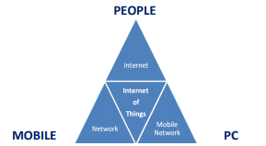

Figure 1 Basics of Internet of Things [1]

Internet of things (IoT) gives a big opportunity to many industries such as automotive field to upgrade the development of new technology in vehicles. IoT is a system of interrelated computing devices, mechanical and digital machines that have ability to transfer data over a network. The uses of IoT in industry significantly influence many applications in modern living. The emerging IoT is going to impact the quality of human lives in many aspects which provide seamless integration of information and communication technologies shortly.

The motivation behind of this project is based on the demand of IoT in automotive industry. The development of an IoT controlled actuator for a vehicle on a chassis dynamometer can make the user’s life easier. This is because the advantage of an IOT controlled test bench is that there is no need for the engineer to stay at the lab where the test is running. This leads to some advantages like that the test engineer is saving time for himself and money for the company because he does not need to setup the test and travel to the location of the lab, which could be somewhere else around the world. Accessibility at any time from any location proceeds to the possibility to check, share and discuss live data from the test bench together with other colleagues. It is even possible to have a look on the information during meetings.

The research project will therefore seek to explore and investigate the following:

* Developing a remotely controlled actuator to control a throttle pedal for vehicles on chassis dynamometers
* Studying the uses of IoT technology in vehicle testing
* Implementing IoT on the controller to control actuator

## Project Scope

The project will consist of developing the remotely controlled actuator via Internet to control the throttle pedal when running on the chassis dynamometer. This project needs approximately RM500 and should be done in 9 weeks starting from 4 March 2019 – 19 May 2019.

## Project Deliverables

* Create an actuator to control a throttle pedal
* Develop a system to control the actuator via internet

## Project Acceptance Criteria

* low latency
* low bandwidth
* real time
* Firm mount of the actuator to allow for accurate movement

## Project Constraints

* Limited budget
* Time / resources / personnel limitations
* Imposed design approach that is beyond the project to change
* Limit or restriction on a facility such as laboratory and workshop
* Procurement practices, procedures or processes that must be followed

# Literature Review

Implementation of IoT system basically depends on its architecture. In the early phase of research, the three-layer architecture was introduced [8] , featuring the perception, network and application layer.

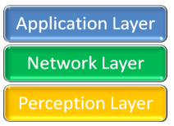

Figure 2 three Layer Architecture [1]

1. Perception Layer - This layer, also called physical layer, gathers data or information and recognizes the physical world. In this layer all the actuators work according to the information which is collected by the sensors of different objects to perform specific operations by the corresponding objects [4].

2. Network Layer - It establishes an interface link between application layer and physical layer. It is responsible for the initial processing of data, broadcasting of data and connecting devices [3].

3. Application Layer – The application layer is the implementation of IoT. The working of sensors and actuators is achieved by application layer. It is represented by software which works on and for the machines and sensors.

This three-layer architecture of Internet of Things is not sufficient for modern technology. A new architecture was designed to define the entire concept and development of IoT devices. The new architecture involves 5 layers and is known as 5 Layer architecture [6]. The new architecture has perception, transport, processing, application and business layers:

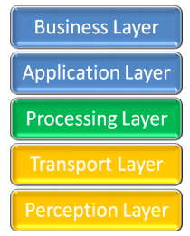

Figure 3 five Layer Architecture [1]

1. Perception layer works similar as previously described in the three-layer architecture. It is used to take information from the sensors and implement it.

2. Transport layer takes the data from the perception layer and pass this data to the next layer which is processing layer and vice versa. This is done with the help of networks like LAN, wireless technology, 3G, 4G, LTE, etc [3].

3. Processing layer, which is the third layer, must perform the major task because it will process all the information gathered by the perception layer. There is a huge amount of data which will be stored with the help of some techniques like cloud computing or any database management system (DBMS). Further it will analyse how to fetch data whenever it is required in order to complete the desired task [5].

4. Application layer is next layer which implements the working of IoT. For this an application is required with the corresponding device in order to complete the desired task.

5. Business layer is the last layer of this architecture which manages the working of the entire system along with many other features as for example privacy [2].

Both of the architectures define the working of IoT systems of different types, but they are following the same sort of working in order to achieve its goal.

# Methodology

To carry out this project we are using the System Development Life Cycle (SDLC). The phases include planning, requirement analysis, design, development, integration and testing, implementation, operation and maintenance.

## Planning

For this project all information and resources where taken from research paper and journal that conduct similar or the same scope as our project. The Project Supervisor will conduct meetings with the team members. Objectives and necessary task are discussed, and the task will be distributed to the team members. Each team members must understand their tasks.

## Requirement Analysis

Before conducting our project, we need to thoroughly go through all the design requirements which includes hardware and software.

Hardware Requirement:

* Linear actuator for physically manipulation of the throttle pedal
* Linear potentiometer for sensing the throttle pedal position

Software Requirement:

* CAD Software – PTC Creo Parametric 5.0
* C/C++ IDE - Visual Studio 2017
* Remote Control UI – Labview (possible)

## Design

From the given requirement, we proposed our design for the task considering all the requirement that is needed to be fulfilled. During the design phase, we design the actuator and circuit along with the system which controls the actuator via internet.

## Development

During the development phase, the hardware and software will be built according to the schedule made at the beginning of the project.

## Integration and Testing

In this phase the system will then be tested together with hardware. We will also check for any mechanical or electrical error, together with identifying bugs in the system.

## Implementation

In implementation phase, any problems in both hardware and software identified in the integration and testing phase need to be resolved.

## Operation and Maintenance

During this phase, the system will be assessed and evaluated. Any potential area for improvement will be determined. Also, there will be some changes made at this stage.

## Materials

|  |  |  |
| --- | --- | --- |
| **No.** | **Items** | **Description** |
| 1. | Linear Actuator | To control the throttle |
| 2. | Sheet metal | Construction of the actuator mount |
| 3. | Motor | To control the throttle |

## Machines

|  |  |  |
| --- | --- | --- |
| **No.** | **Items** | **Description** |
| 1. | Chassis Dynamometer | To run vehicle and collect data |

Electrical Systems

|  |  |  |
| --- | --- | --- |
| **No.** | **Items** | **Description** |
| 1. | Linear potentiometer | Sensor for closing the control loop of the actuator position |
| 2. | Raspberry Pi | Microcontroller to receive remote control data and control the actuator |
| 3. | Speed controller (ESC) for actuator | Final stage to drive the actuator motor with the control signal from the microcontroller |
| 4. | Power supply (PSU) | 220V PSU or 12V capability |
| 5. | Input connector/cable to dyno | Possible speed signal, to remotely control the speed |
| 6. | 5V Relay | Reduce current flow |

## Tools

|  |  |  |
| --- | --- | --- |
| **No.** | **Items** | **Description** |
| 1. | Welder | Required for the metal construction of the actuator mount |
| 2. | Plasma cutter/table | Required for cutting sheet metal for the actuator mount |

# Manual Design Calculation and CAD Drawing



Figure 4 Schematic of setup

|  |  |
| --- | --- |
| Possible solution | Notes |
| Real vnc x ming x server | Remote desktop, live control of the raspberry pi high latency high amount of datatransfer |
| Sql Database with LabView +vpn | Simulation of a local network through vpn |
| Raspberry pi hosts a webpage | Compatibility Inputoptions limited |
| ftp | Slow, no real time |

Figure 5 evaluation of remote controle solutions



Figure 6 Mindmap

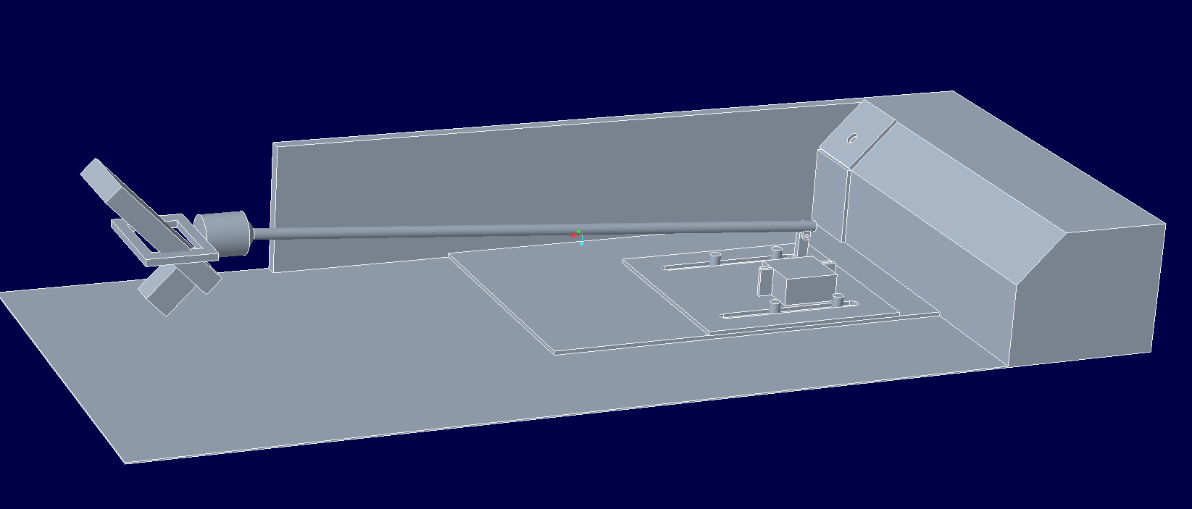

Figure 7 accurate space model of footspace, throttle, mounting and actuator

# Selection of Criteria

|  |  |  |  |  |  |  |  |
| --- | --- | --- | --- | --- | --- | --- | --- |
| *actuator to push the trottle* | **easy assembly** | **price** | **displacement/angle per time** | **force/torque** | **control** | **number of + signs** | **weighting** |
|
| **"+"** | **gK** |
| **easy assembly** |  | **+** | **-** | **-** | **-** | 1 | 0,13 |
| **price** | **-** |  | **-** | **-** | **-** | 0 | 0,00 |
| **displacement/angle per time** | **+** | **+** |  | **o** | **-** | 2 | 0,25 |
| **force/torque** | **+** | **+** | **o** |  | **o** | 2 | 0,25 |
| **control** | **+** | **+** | **+** | **o** |  | 3 | 0,38 |
|  |  |  |  |  |  |  |  |
|  |  | | | |  | **8** | **1,00** |

# Actuator comparison

|  |  |  |
| --- | --- | --- |
| **article** | Servo Motor | Linear Actuator |
| **picture** |  |  |
| **Link** | <https://shopee.com.my/JX-CLS6336HV-Digital-Metal-Gear-Coreless-Motor-Servo-35.6kg-Torque-Aluminum-fyfb-i.111564047.1921093403> | <https://www.lazada.com.my/products/12v-200n-100150200300mm-linear-actuator-motor-stroke-electric-door-opener-i441685108-s652625813.html?spm=a2o4k.searchlist.list.78.981f35f9NWysCK&search=1> |
| **easy assembly** | easy attachment of lever servo motor might constantly power to hold the torque | direct mounting to throttle |
| **price** | RM120.05 | RM103.23 |
| **displacement /angle per time** | 545°/s | 30mm/s |
| **force/torque** | 35,6kNm | 200N |
| **control** | Controllable angle range from 0 to 180 degrees with a PWM signal | 0V to 12V to drive forward 0V to -12V to drive reverse no feedback about position  need of a displacement measurement |

# Detailed Cost Estimation

|  |  |  |  |  |
| --- | --- | --- | --- | --- |
| **Items** | **Image** | **Estimated unit price** | **quantity** | **Total price** |
| Servo Motor/Linear Actuator |  | 75-150RM | 1-2 | 150-300RM |
| Linear potentiometer |  | 5RM | 1 | 5RM |
| Coaxial Ball joint |  | 27,70RM | 2 | 55,4RM |
| Ball joint |  | 12,02RM | 1 | 12,02 |
| Servo Arm (Aluminium) |  | 5RM | 1 | 5RM |
| Sheet metal, rods, nuts, screws |  | 100RM | 1 | 100RM |
| Power supply |  | 100RM | 1 | 100RM |
| TOTAL ESTIMATED BUDGET (MAXIMUM RM500) | | | | 427-582RM |

# Expected Testing Results

At the end of this project we are expected to have a remotely controlled actuator which controls the car throttle pedal position on a chassis dynamometer.

# Conclusions

The actuator that will be developed can be controlled by an online controller. A lot of work is needed to be done for the improvement and progress of this project; still more standardization of technology, and hardware are required to make completely reliable and secure use of Internet of Things possible. Some global guidelines need to be used for this purpose. The future is totally depending on Internet of Things, so there are lot of things to do at the current implementation level.

# Project Gannt Chart

|  |  |  |  |  |  |  |  |  |  |
| --- | --- | --- | --- | --- | --- | --- | --- | --- | --- |
| Activities | 4-24  March | 25-31 March | 1-7 April | 8-14 April | 15-21 April | 22-28 April | 29-5 April/May | 6-12 May | 13-19 May |
| Project Briefing, Team Building, Introduction to LabView an Raspberry Pie |  |  |  |  |  |  |  |  |  |
| Project Proposal |  |  |  |  |  |  |  |  |  |
| Programming of Remote control (LabView, Python, Android/Windows) |  |  |  |  |  |  |  |  |  |
| Sketching & CAD Drawing of actuator mounting |  |  |  |  |  |  |  |  |  |
| Choose actuators and sensors |  |  |  |  |  |  |  |  |  |
| Order of Parts and Materials |  |  |  |  |  |  |  |  |  |
| Assembling Parts |  |  |  |  |  |  |  |  |  |
| Testing |  |  |  |  |  |  |  |  |  |
| Report Preparation |  |  |  |  |  |  |  |  |  |

# Team Organisation

|  |  |  |  |
| --- | --- | --- | --- |
|  | Nurain Binti Rozy | HB15033 | UMP |
|  | Muhammad Syakir Bin Turiman | HB15024 | UMP |
|  | Muhammad Nor Azril Bin Zulkafli | HB15011 | UMP |
|  | Lorenz-Leo Wilhelm | HB18026 | HsKa |
|  | Uli Michael Hochreither | FB18161 | HsKa |
|  | Jakob Kleikamp | HB18025 | HsKa |

# References

[1] Int. J. Advanced Networking and Applications, Krishan Kumar Goyal, Volume: 09 Issue: 06 Pages: 3663-3668 (2018) ISSN: 0975-0290

[2] A. Al-Fuqaha, M. Guizani, M. Mohammadi, M. Aledhari, and M. Ayyash, "Internet of things: A survey on enabling technologies, protocols, and applications," IEEE Communications Surveys & Tutorials, vol. 17, pp. 2347-2376, 2015

[3] Miao W., Ting L., Fei L., ling S., Hui D., 2010. Research on the architecture of Internet of things. IEEE International Conference on Advanced Computer Theory and Engineering (ICACTE), Sichuan province, China, Pages: 484-487.

[4] Yinghui H., Guanyu L., 2010. Descriptive Models for Internet of Things. IEEE International Conference on Intelligent Control and Information Processing, Dalian, China, Pages: 483- 486

[5] Pallavi Sethi and Smruti R. Sarangi, “ Internet of Things: Architectures, Protocols, and Applications,” Journal of Electrical and Computer Engineering Volume 2017, Article ID 9324035, 25 pages.

[6] Handong Zhang and Lin Zhu, "Internet of Things: Key technology, architecture and challenging problems," 2011 IEEE International Conference on Computer Science and Automation Engineering, Shanghai, 2011, pp. 507-512.

# Table of Figures

Figure 1 Basics of Internet of Things [1] 2

Figure 2 three Layer Architecture [1] 4

Figure 3 five Layer Architecture [1] 5

Figure 4 Schematic of setup 8

Figure 5 evaluation of remote controle solutions 8

Figure 6 Mindmap 9

Figure 7 accurate space model of footspace, throttle, mounting and actuator 9